|  |
| --- |
| **<Sort&Earn-A Platform App for Garbage Sorting and Recycling>** |
| **Group: <33>** |
| ***EBU5608 Product Develoment and Management*** |
|  |
| **Group Members:**  <Ling Tang 221169302, 22022213457 >  <Yuxuan Zhong 221169092, 2022213435 >  <Shuyi Wei 221169276, 2022213454 >  <Zhimu Zhou 221169324, 2022213459>  <Zuocheng Zuo 221169081 2022213434> |
|  |
| Report Word Count: 3774 |
|  |
| **<BEFORE SUBMITING REPORT PLEASE DELETE THIS FOLLOWING MESSAGE >**  This document has been formatted in order for you to use as a template to produce your report. There are no restrictions on the layout of the diagrams and tables. A predefined contents list has been generated with headings for your report. You can add more to the contents list by inserting different levels of heading for each sub section within the report.  NOTE: The contents list is automated and can be updated by simply right clicking on it and clicking update field.  The report must be no more than **4000 words** (**NOT** including the Table of Contents, List of References) and it is acceptable to use figures, diagrams and tables where relevant. You will get penalised 1 mark for every 100 words you go over, So make sure you focus on quality rather quantity.  Your submitted Word file must not be bigger than 1MB |

Table of Contents

Summary of Responsibilities 3

Individual Member 1 (Group Leader) Contribution: <Ling Tang> 3

Individual Member 2 Contribution: <Zhimu Zhou> 3

Individual Member 3 Contribution: <Shuyi Wei> 3

Individual Member 4 Contribution: <Yuxuan Zhong> 3

Individual Member 5 Contribution: <Zecheng Zuo> 4

Introduction 5

Opportunity Identification 6

Step 1: Establish a charter 6

Step 2: Generate and sense many opportunities 6

Step 3: Screen opportunities 7

Step 4: Develop promising opportunities 7

Step 5: Select exceptional opportunities 8

Step 6: Reflect on the result and process 10

Identification of Customer Needs 12

Step1 Gather raw data from customers 12

Step2 Interpret the raw data in terms of customer needs 14

Step3 Organize the needs into a hierarchy of needs 15

Step4 Establish the relative importance of the needs 15

Step5: Reflect on the results and the process 16

Concept Generation and Testing 18

Concept Generation 18

Step1: Clarify the questions 19

Step2: Seek For solutions 19

Step3: Designing Product Functional Flow 22

Step4：Confirmation of platform functionality presentation and UI design 23

Testing 24

Step1: Profit Model Analysis 24

Step2: Market feasibility analysis 25

Step3: Target Market Analysis 25

Conclusion 26

List of References 27

Appendix 27

# Summary of Responsibilities

## Individual Member 1 (Group Leader) Contribution: <Ling Tang>

She interpreted raw data in terms of customer needs in “identify customer needs” section.

She wrote the “REAL-WIN-WORTH-it” charts to select a few that are most worthy of investment in “identify customer needs” section.

She completed “Interpret raw data in terms of customer needs” and “Establish the relative importance of the needs” in “identify customer needs” section.

She organized the customers’ need into hierarchy in “identify customer needs” section.

She design the questionnaire and analyzed it in “concept generation and testing” section.

She reflected on the results and the process after identifying customer needs in “identify customer needs” section.

She did the customer interviews in “identify customer needs” section.

## Individual Member 2 Contribution: <Zhimu Zhou>

She is responsible for the part of concept generation and testing.

She designed the prototype of the product and made sure the technique details of the product.

She designed the application working process for company and platform users.

She designed the UI design and system structure of platform.

She is responsible for integration of the final report.

She is responsible for the modification of all parts.

**Individual Member 3 Contribution: <Shuyi Wei>**

She primarily conducted a profit model analysis, identifying revenue sources and the company's profit strategy.

She provided detailed descriptions of recycling spread, mall goods profit, advertising fees, and information fees, outlining the expected revenue.

She conducted a comprehensive feasibility analysis of the market, examining both the market basis and competitive advantages.

She highlighted the significant potential of China's waste separation and recycling market, along with the technological competitive advantages of the "Sort&Earn" app.

She identified the target market and conducted in-depth analysis.

She determined the target market by designing a questionnaire surveying random samples from various neighborhoods in Beijing and drawing conclusions through statistical analysis.

## Individual Member 4 Contribution: <Yuxuan Zhong>

He set the problem statement and the product idea.

He is responsible for the part of introduction, opportunity identification from step 5 to step 6 and the mission statement.

He designed charters illustrating the value of the product.

## Individual Member 5 Contribution: <Zecheng Zuo>

He is responsible for the part of opportunity identification from step 1 to step 4 and conclusion.

He searched for the opportunities of the product and identified some of them.

# Introduction

Sort&Earn is committed to pioneering sustainable change in the recycling sector. Our core mission is to enable individuals and communities to play a significant role in ecological preservation through our accessible digital platform. Designed to demystify recycling logistics, the platform educates on proper waste segregation and offers tangible rewards for responsible environmental actions. Our integration of advanced technology with a dynamic reward system is aimed at elevating recycling rates, minimizing landfill dependency, and nurturing an ethos of sustainability. We envision a frictionless recycling ecosystem that conserves resources while improving societal well-being. In pursuit of excellence and community partnership, Sort&Earn aspires to lead in environmental guardianship, propelling us towards a greener tomorrow.

# Opportunity Identification

## Step 1: Establish a charter

Considering the strengths of our company in all aspects, we set a charter that articulated our goals and boundary conditions for an innovation effort.

1. Define the Purpose: Clearly state the purpose of the product. What need does it address?
2. Outline the Goals: Specify what the project aims to achieve. These should be measurable and aligned with the overall business objectives.
3. Set Boundaries: Define what is in scope and out of scope for the project. This helps in focusing the efforts and resources on what’s most important.
4. Identify Resources: List the resources available for the project, including team members, technologies, and budget.
5. Timeline: Provide a clear timeline with milestones for the development and launch of the product.
6. Risk Management: Identify potential risks and their mitigation strategies to preemptively address challenges that might arise.

Charter: "Develop and deploy a mobile application-based recycling service that leverages QR code technology to facilitate waste separation and recycling, enhancing community recycling efforts and integrating educational and promotional activities to foster a culture of environmental responsibility."

## Step 2: Generate and sense many opportunities

Based on the internal and external sources described for generating raw opportunities suitable for our company, here is a revised summary of the potential opportunities:

**1.Innovative Recycling Process**: Utilizing mobile app and QR code technology, the product streamlines the recycling process making it more efficient and user-friendly. This is likely to attract users who value convenience and environmental responsibility.

**2. Educational Impact**: By integrating educational campaigns about recycling within the app, the product has the opportunity to increase awareness and change behaviors related to waste management in urban environments.

**3.Partnership and Government Support**: The product is poised to benefit from governmental incentives for environmental initiatives, as well as potential partnerships with educational institutions and residential communities which can provide a steady user base.

**4.Market Expansion**: There is an opportunity for market expansion into other regions beyond Hangzhou, especially in areas with high smartphone penetration and environmental consciousness.

**5. Data Collection and Management**: The app collects valuable data on consumer recycling habits, which can be used to improve municipal waste management strategies and offer targeted advertisements, creating additional revenue streams.

Raw Opportunities Generated:

* Garbage Recycling Online Platform: Make a platform that can motivate users to recycle garbage and waste products, and correctly delivering them can also gain points to exchange for corresponding commodities, and contact waste companies through the platform for reasonable recycling.
* Intelligent garbage recycling bins: using the Internet + intelligent recycling, through the only garbage classification involved in the pen to guide the public to form the habit of active classification, the equipment appearance is stylish, easy to operate, to help the user to classify and recycle garbage waste products.
* Garbage sorting robots: Development of robots that can automatically sort garbage. These robots use machine vision and artificial intelligence technology to improve the efficiency and accuracy of sorting at garbage collection stations.

## Step 3: Screen opportunities

Faced with the five raw opportunities, we held a meeting to discuss and vote to choose the products that were more competitive, more worthy of further investigation and more likely to be profitable. **In this step we eliminated the opportunity of Market Expansion.**

The result of multi-voting is as follows:

|  |  |
| --- | --- |
| **Opportunity** | **The results of volting(Out of 5)** |
| **Innovative Recycling Process** | 5 |
| **Educational Impact** | 3 |
| **Partnership and Government Support** | 4 |
| **Market Expansion** | 2 |
| **Data Collection and Management** | 4 |

Table 1. The result of multi-voting

## Step 4: Develop promising opportunities

In our focused efforts to refine our product opportunities, the team engaged in concept generation and customer interviews for the remaining three initiatives after deciding against the nutritional diet app due to lack of market enthusiasm and potential overlap with existing services. Here are the revised analyses:

Concept Generation:

**Innovative Recycling Process**: We conceptualized an app that simplifies the recycling process through mobile technology and QR codes, enhancing user experience and efficiency.

**Educational Impact**: We envisaged integrating educational content on recycling within the app to increase environmental awareness and influence waste management behaviours in urban settings.

**Partnership and Government Support**: We saw the potential for the app to align with government incentives for environmental initiatives and to build partnerships with educational institutions and residential communities, thus ensuring a consistent user base.

**Customer Interviews**: Feedback from varied demographics gave us a clear picture:

From Classmates: Their input suggested that our app's success would hinge on differentiating from pre-existing platforms and offering unique, value-added features that go beyond mere convenience.

From Teachers: Educators encouraged us to consider the evolving market and to aim for a product with multifunctional capabilities, potentially expanding beyond educational aspects to offer a more comprehensive suite of services.

**Resolution**: Armed with these insights, the team decided to proceed with the innovative recycling process, the educational impact initiatives, and to leverage partnerships and government support to ensure the app's relevance and utility.

## Step 5: Select exceptional opportunities

In this section, we applied the "Real-Win-Worth-it" framework to identify the most promising investment opportunity. The charts below illustrate the RWW criteria used for the Garbage Sorting and Recycling opportunity. Through this process, **we pinpointed an outstanding product opportunity: the development of a platform app for garbage sorting and recycling.**

1. Is the opportunity real?

|  |  |
| --- | --- |
| **Questions to ask** | **Yes/No** |
| **Is there a need? (What is the need?)** | Yes. Urban communities require efficient waste management systems. Sorting and recycling reduce landfill use and promote sustainability. |
| **How is the need currently satisfied?** | Waste is managed through traditional collection and disposal methods, with limited incentive for recycling and sorting at the individual level. |
| **Can the customer buy? (Size of the market, customer decision-making process)** | Yes. The customer base includes smartphone users interested in environmental conservation, which is a growing segment. |
| **Will the customer buy? (Perceived risks & benefits, expectations on price and availability)** | Yes. By providing incentives like redeemable points for sorted waste, customers are more likely to participate in the recycling program, seeing both personal and environmental benefits. |
| **Is there a viable concept for the product already? (How likely are we able to develop a viable concept?)** | Yes. The concept of incentivizing recycling through an app is proven and viable, with clear user and environmental benefits. |
| **Is the product acceptable within the social, legal, and environmental norms?** | Yes. The app promotes environmentally responsible behavior, complies with regulations, and aligns with societal trends towards sustainability. |
| **Is the product feasible? Can it be made? Is the technology available? Does it satisfy the needs?** | Yes. The technology to track and reward recycling activities is available, and the app is feasible to build and deploy. |
| **Will our product satisfy the market? Is there a relative advantage to other products?** | Yes. The app differentiates itself by offering a user-friendly platform that not only simplifies recycling but also rewards users, providing a clear advantage over traditional waste management systems. |
| **Can it be produced at low cost?** | Yes. The app can be developed and maintained with reasonable investment, with potential for high returns due to its scalability and low incremental costs. |
| **Are the risks perceived by the customer acceptable? What are the barriers to adoption?** | Yes, the risks are minimal as the app is free to use and provides benefits. Barriers such as user adoption and habit change are mitigated through education and rewards. |

Table 2. Q&A about "Is the opportunity real?"

2. Can you win with this opportunity?

|  |  |  |
| --- | --- | --- |
| **Questions to ask** | | **Yes/No** |
| **Do we have a competitive advantage?** | Yes. Our app incentivizes garbage sorting and recycling in a user-friendly manner, which is a novel approach compared to traditional waste management systems. | |
| **Is it sustainable? (Performance, patents, barriers to entry, substitution, price)** | Yes. The app's model is sustainable, with planned patent applications for unique features to protect the technology and create barriers to entry for potential competitors. | |
| **Is the timing right?** | Yes. With increased environmental awareness and the push for sustainable living, launching a garbage sorting app aligns well with current consumer trends. | |
| **Does it fit our brand?** | Yes. The app aligns with our company's mission to promote environmental sustainability and integrate technology with eco-friendly practices. | |
| **Will we beat our competition? (How much will they improve? Price trajectories, entrants)** | Yes. Our app's unique reward system and data-driven insights offer a significant edge over traditional recycling programs, which are often perceived as inconvenient and unrewarding. | |
| **Do we have superior resources? (Engineering, finance, marketing, production; fit with core competencies)** | Yes. Our resources include a skilled engineering team experienced in app development, strong financial backing, an innovative marketing strategy, and established relationships with recycling companies. | |
| **Do we have the management that can win? (Experience? Fit with culture? Commitment to this opportunity?)** | Yes. The management team has a track record of successful environmentally-focused projects, embodying the company's culture and demonstrating a strong commitment to making recycling accessible and rewarding. | |
| **Do we know the market as well as or better than our competitors? (Customer behavior, channels?)** | Yes. We have conducted extensive market research, including surveys and user behavior studies, which gives us in-depth insights into customer needs and the most effective channels for engagement. | |
| **Do we have a competitive advantage?** | Yes. Our app incentivizes garbage sorting and recycling in a user-friendly manner, which is a novel approach compared to traditional waste management systems. | |

Table 3. Q&A about "Can you win with this opportunity?"

3. Is it worth doing?

|  |  |
| --- | --- |
| **Questions to ask** | **Yes/No** |
| **Will it make money?** | Yes. The platform app is designed to generate revenue through partnerships with recycling companies, in-app advertising, and potential data analysis services for urban planning and environmental agencies. |
| **Do we have the resources and the cash to do this?** | Yes. With financial backing from eco-conscious investors and grants aimed at sustainability projects, as well as in-house technical expertise, we are well-equipped to develop and launch the app. |
| **Are the risks acceptable to us? (What could go wrong? Technical risk versus market risk)** | Yes. While there are risks such as user adoption rates and the accuracy of the sorting technology, these are manageable with ongoing development and a robust marketing strategy aimed at user engagement and education. |
| **Does it fit our strategy? (Fit with our growth expectation, impact on brand, embedded options)** | Yes. The app supports our strategic goal of integrating innovative technology with sustainable practices and has the potential to enhance our brand as a leader in environmental tech solutions. |
| **Will it make money?** | Yes. The platform app is designed to generate revenue through partnerships with recycling companies, in-app advertising, and potential data analysis services for urban planning and environmental agencies. |

Table 4. Q&A about "Is it worth doing?"

## Step 6: Reflect on the result and process

Reflective consideration enables us to identify current issues and also aids in enhancing our productivity for the subsequent phase. Upon review, the prospects proved to be practical.

Initially, our group evaluated numerous potential ventures from both internal and external origins. Moreover, the innovation charter precisely delineated the institution's objectives. Its broad scope provided us with a greater range of possibilities than anticipated. Additionally, our selection process was impartial, centered on the likelihood of the end product's successful realization. Consequently, the opportunities that emerged invigorated our team and met the collective anticipations of all members.**Mission Statement**

Product Description

* Our mission is to deliver an innovative mobile application that revolutionizes the way communities engage with garbage sorting and recycling.
* The app rewards eco-friendly behavior with a points system, transforming recycling from a duty into a rewarding experience.
* It educates and empowers users, promoting sustainable practices that contribute to a healthier planet.

Key Business Goals

* To reach a milestone of 1 million app downloads by 2025, reflecting widespread adoption and a strong market presence.
* To establish the app as a leader in the digital environmental solutions space, aiming for a 40% market share.
* To be recognized as a catalyst for change, accelerating the transition to energy-efficient and sustainable waste management practices.

Primary Market

* Targeting households that are becoming increasingly environmentally aware and are looking for accessible means to contribute positively to the planet.
* Catering to eco-conscious individuals who value sustainability and are motivated by gamified experiences that reward green behavior.

Secondary Market

* Extending our reach to educational institutions and corporate entities seeking to implement and reinforce responsible waste management practices among students and employees.
* Collaborating with environmental organizations that can utilize the app as a tool to enhance their community outreach and engagement.

Assumptions and Constraints

* Operations leverage robust and scalable technology infrastructure, designed to handle a large and growing user base.
* The adoption of the app is dependent on the continuous evolution of smartphone technology and the increasing ubiquity of mobile devices.
* Market expansion is contingent upon ongoing user education and the breaking down of traditional barriers to recycling.
* Our growth is subject to our ability to navigate and comply with varying international waste management policies and regulations.

# Identification of Customer Needs

We use the Ulrich and Eppinger's five-steps process to identify customer needs for our product.

## Step1 Gather raw data from customers

In order to deeply understand the needs of users for garbage sorting and recycling apps, our team has adopted a variety of ways to collect raw data. First of all, we designed and distributed questionnaires to directly target potential users, including students, faculty and staff of higher education parks, property management personnel, residents of the community and waste recyclers, in order to obtain their real views and specific needs for garbage sorting and recycling services.

We chose questionnaires as the primary method of raw data collection because they provide direct feedback from users, have a wide range of coverage, and are relatively inexpensive.

In order to ensure the effectiveness and universality of the questionnaire, we distributed more than 1000 questionnaires in higher education parks and middle and high-end communities, and successfully recovered more than 900 valid questionnaires. In addition, we also distributed and collected 20 questionnaires specifically for waste recyclers to understand their views and needs for waste separation and recycling services.

Through these questionnaires, we have collected a large amount of valuable first-hand data, which provides a solid foundation for subsequent data analysis and product demand identification.

Only the data results of the questionnaire are presented here. Please refer to the appendix for specific questionnaire information Questionnaire survey for community use.

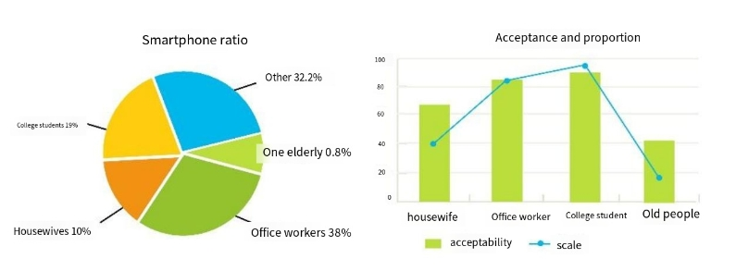

Figure 1. The result of smartphone ratio & acceptance and proportion

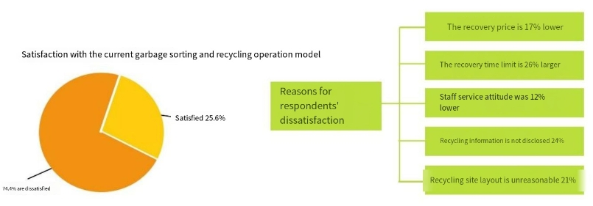

Figure 2. The result of satisfaction with the current garbage sorting and recycling operation model & reasons for respondents’ dissatisfaction

1. Questionnaire for higher education parks

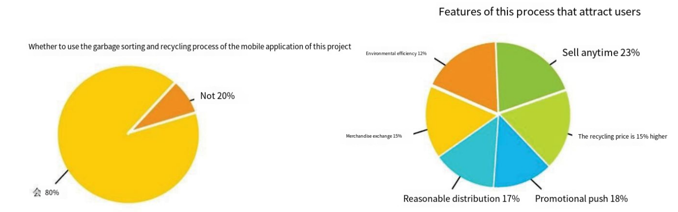

Figure 3. 80% respondents use the garbage sorting and recycling process of the mobile application of the project & features of the process that attract users

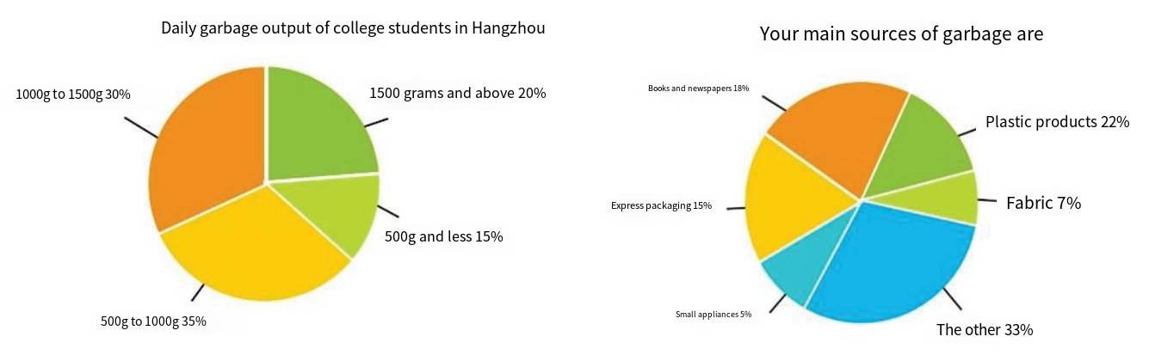

Figure 4. Daily garbage output of college students in Hangzhou & The main sources of garbage

1. Questionnaire for waste recyclers

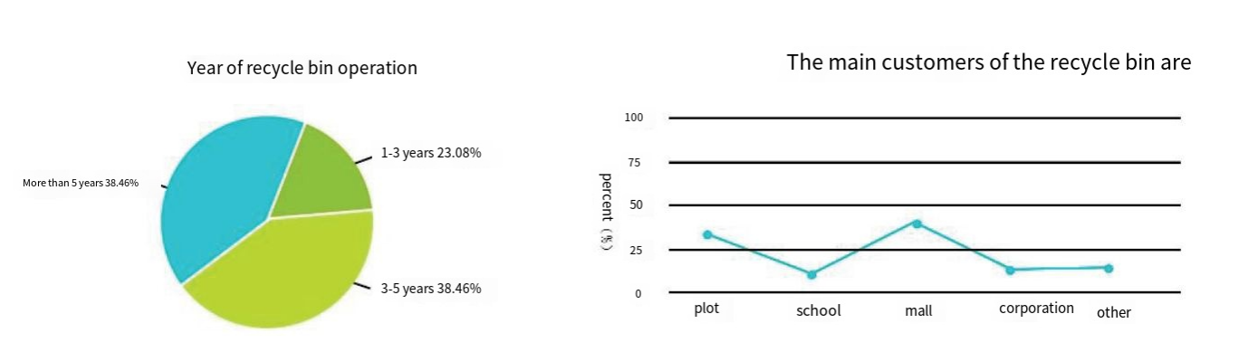

Figure 5. Years of recycle bin operation & The main customers of the recycle bin

**Comprehensive analysis of questionnaire**

The elderly and housewives are the main groups for scrap sales (70%), but the acceptance of garbage sorting and smartphone usage are low.

Although college students do not account for a high proportion of waste sales (20%), they have a high acceptance of waste sorting (92%) and a high penetration rate of smart phones (95%), indicating a huge market potential.

Only 26.2 percent of respondents were satisfied with the current waste recycling market, while 74.4 percent were dissatisfied. The main reasons for dissatisfaction included large recycling time limit (26.6%) and lack of disclosure of recycling information (24%).

Different from ordinary users, more than 55.5% of waste recyclers have established a perennial waste recycling agreement with large waste recycling enterprises, and 56% of waste recyclers said that although they understand the garbage classification recycling mode, 42.5% of waste recycling is mainly through door-to-door recycling, and 36.8% of store recycling

42% of recyclers expressed interest in the project's app-based recycling model.

80% of the respondents recognized the waste recycling process of mobile applications, valuing its environmental protection, efficiency, convenience and other characteristics, in line with the preferences and consumption power of young consumer groups.

## Step2 Interpret the raw data in terms of customer needs

In the previous step, we got a number of responses about needs from potential customers. Therefore, in this step, we committed ourselves to interpreting needs as attributes of our product. Besides, we changed all statements into positive phrasing. Some transformation we did between needs and attributes are attached as follows: 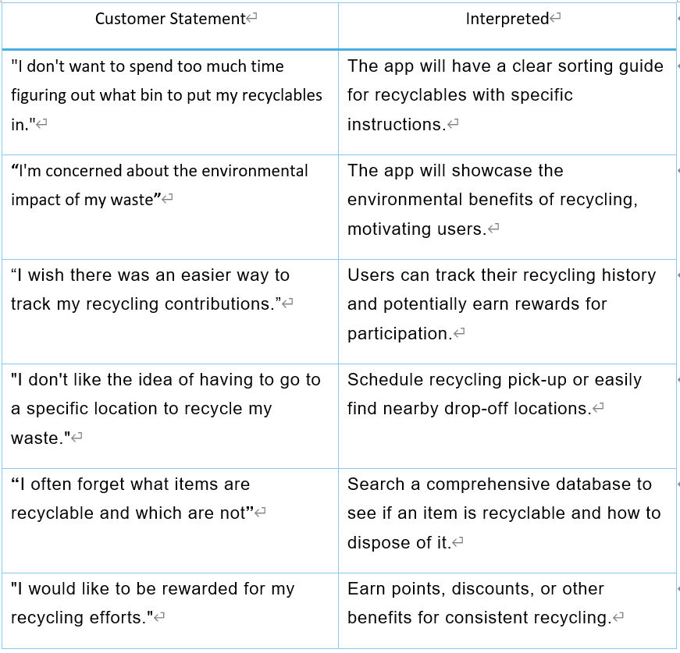

Figure 6. The corresponding interpretation of customers’ statements

## Step3 Organize the needs into a hierarchy of needs

In this step, we structured the needs into four groups, which showed as the following figure. After we did this classification, we could better design our products in the order of importance and hierarchy.

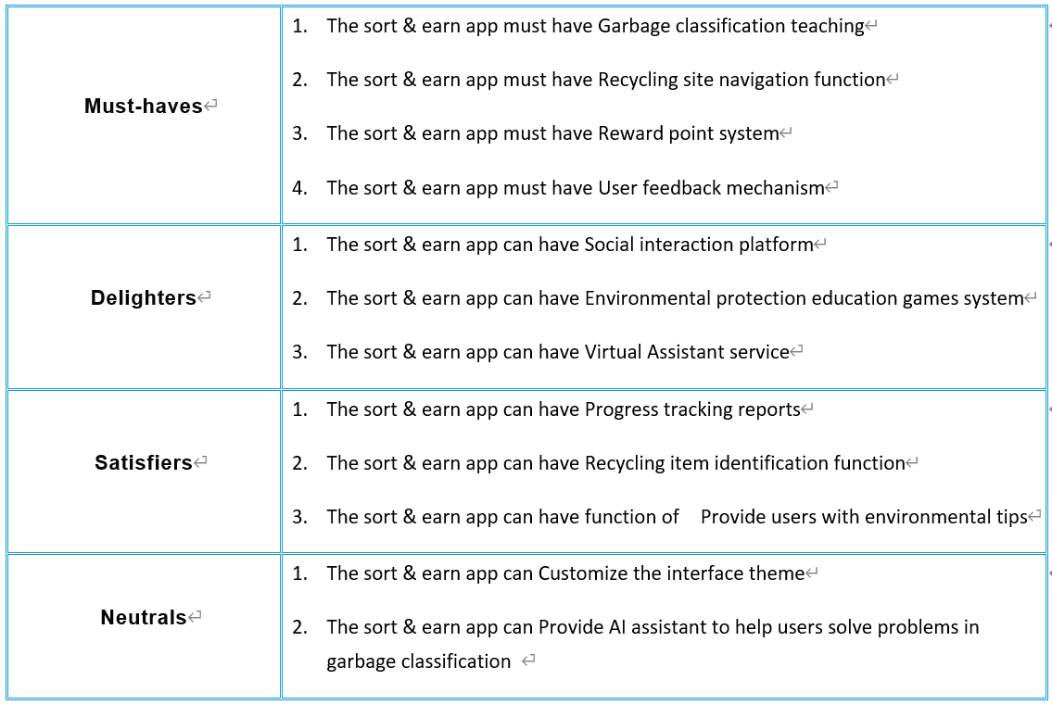

Figure 7. Organize the needs into a hierarchy of needs

## Step4 Establish the relative importance of the needs

We did a survey in order to measure consumers’ preferences, so as to establish the relative importance of the needs. This definitely helped our organization build product concepts, as well as the manufacturing process

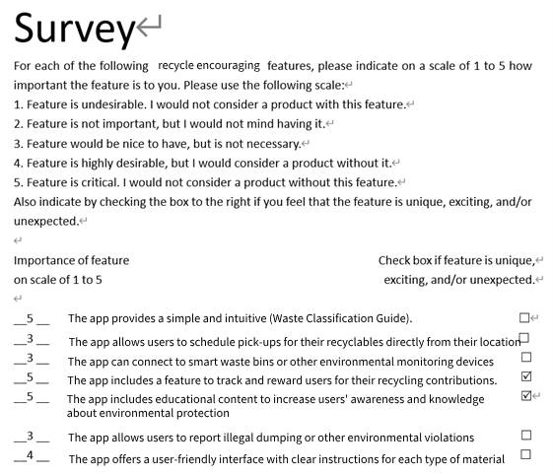

Figure 8. Information of the survey

## Step5: Reflect on the results and the process

In the real product development, it was impossible for us to complete every steps perfectly, so the timely reflection after the investigation was necessary. We reflected the above process by asking the questions as follows:

1. Have we interacted with all important customers in our target market?

Yes, our team has successfully interacted with a diverse range of potential users within our target market for the garbage classification and recycling app. We distributed questionnaires to residents of high-education parks and residential communities, as well as waste recycling merchants.

2. Can we see the latent needs of customers beyond our current product range?

Absolutely. The data collected from the surveys revealed several latent needs that extend beyond the current scope of our product.

3. Can we further involve any of the customers in our product development?

Certainly. There is significant potential to involve customers more deeply in the product development process. Additionally, we could host workshops or ideation sessions to brainstorm and co-create solutions with our users, ensuring that the product evolves to meet their needs and expectations.

4. Did we involve the right people in our organization?

Yes, our team comprises individuals with diverse skills and expertise necessary for the development of a comprehensive waste management app

5. Can we improve our process?

There is always room for improvement. Upon reflection, we identified several areas where our process could be enhanced. Lastly, continuous iteration and user testing throughout the development process would ensure that the final product is refined and optimized based on user feedback.

Who and what customers are or could be interested in your product/service idea?

1. Environmentally conscious residents, particularly from high-density urban areas and educational parks, seeking efficient recycling solutions.
2. Businesses and institutions looking to enhance their sustainability efforts and promote eco-friendly practices.
3. Local government and environmental organizations in search of innovative waste management strategies.
4. Educators and students using the app as an educational tool for environmental awareness and sustainable living.

# Concept Generation and Testing

## Concept Generation

In this section, we first used the flowchart to identify the functions in our project that correspond to user needs, and then designed the UI display and function disassembly. We think our project should motivate users to classify and recycle garbage through the point reward system, and enhance the public's awareness of environmental protection. Below is the complete functionality and description of our platform.

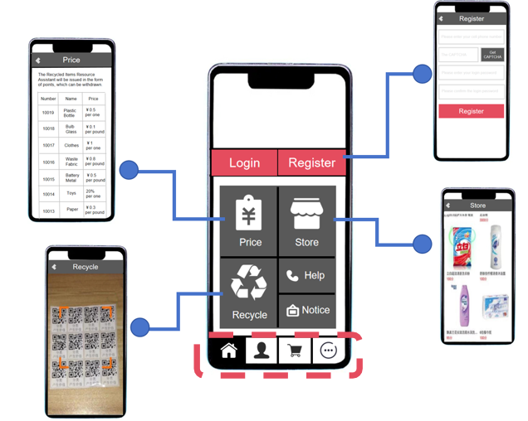

Figure 9. The complete functionality and description of our platform(1)

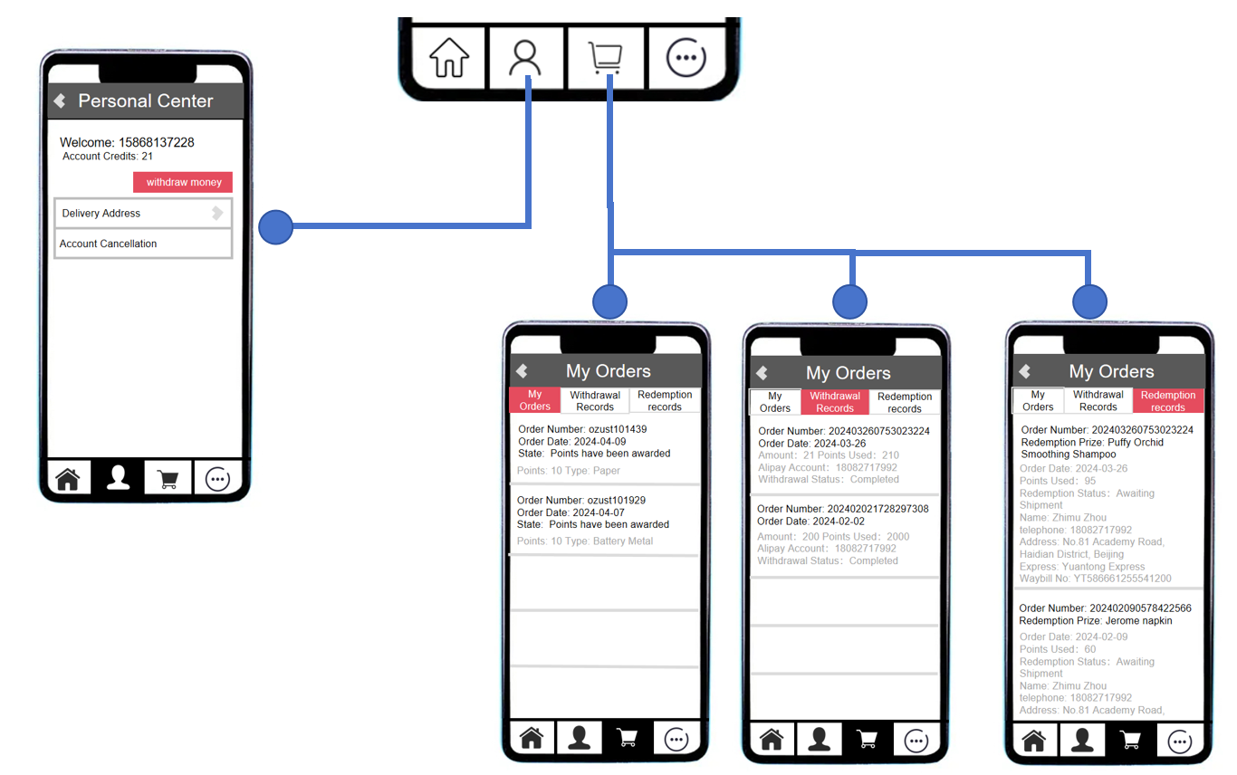

Figure 10. The complete functionality and description of our platform(2)

## Step1: Clarify the questions

1. The platform needs to be user-friendly and can be lightly loaded on WeChat applets or websites.
2. The platform needs to provide users with complete waste classification and recycling services through external devices, including platform-specific waste recycling bins, QR codes for recycling of waste goods, etc.
3. The platform needs to record users' personal information securely and accurately, and beware of platform data leakage.
4. The platform should use a point reward system as the main function to increase user stickiness and help recycling companies expand their business in order to reach a virtuous cycle in the market.
5. The platform needs to be closely integrated with community operation to complete the product usage chain: learning - practicing - sorting and recycling - motivating - learning again.

## Step2: Seek For solutions

Once the direction of the requirements was basically defined through the requirements, we disassembled the requirements into sub-problems in specific technical areas and selected solutions that fit the tonality of this product.

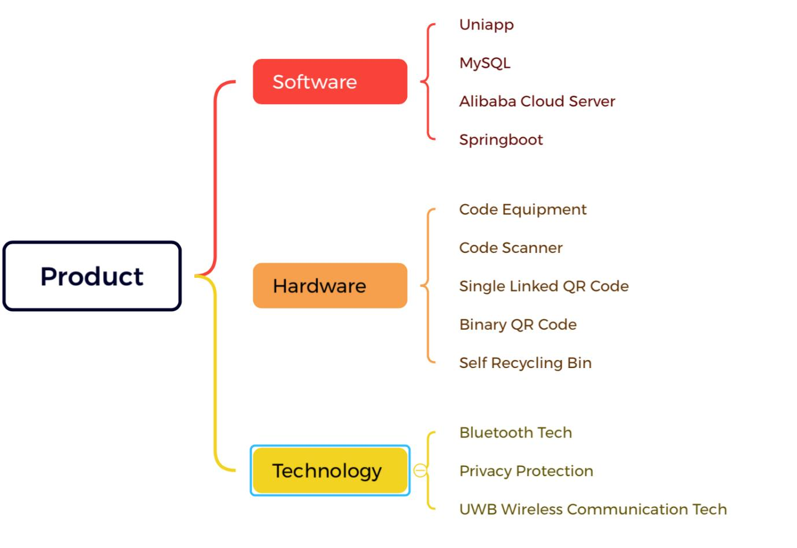

Figure 11. The corresponding solutions for requirements

1. Software:

We piggyback the platform to run in a WeChat applet, and the database uses a MySQL database for data storage and recording. We plan to use Uniapp for the development of the platform, and the back-end uses SpringBoot to integrate the front-end with the database to take on the function of data processing and transmission. In terms of remote operation and multiple storage, we choose to use Ali Cloud servers to carry the entire platform, to ensure the efficiency and large capacity of data transmission and storage.

1. Hardware:

We mainly choose weighing equipment and code scanners, QR codes and autonomous recycling bins to improve the function of waste classification and recycling.

|  |  |  |
| --- | --- | --- |
|  | weighing equipment and code scanners | Weighing equipment and scanners work in tandem to generate the appropriate basic information about the items in the platform, such as weight, type of recycling, etc. |
|  | Single QR code | The single link QR code confirms the information and binds the product by scanning it with your cell phone. |
|  | Two-link QR code | Users affix one link to the recycling bag to confirm the user's information, and the other link is kept by the user for redemption of points. |
|  | Self-service recycling bins | Self-service recycling bins are equipped with five waste disposal ports: paper, plastic bottles, metal, glass and others, and the items can not be taken out once put in, to ensure the safety of the user to put in the waste. |

Table 4. Hardware apparatus of the platform

1. Technological aspects:
2. Bluetooth technology, which is the fusion of wireless communication and data communication. The technology is based on low-cost, near-field wireless connections that can set up communication environments for both fixed and mobile devices (Li & Zhao, 2001).
3. UWB wireless communication technology, which includes wireless communication and positioning functions. lt has high data transmission rate and well-performed security. Users can find near by users quickly (Oppermann, I., 2004).

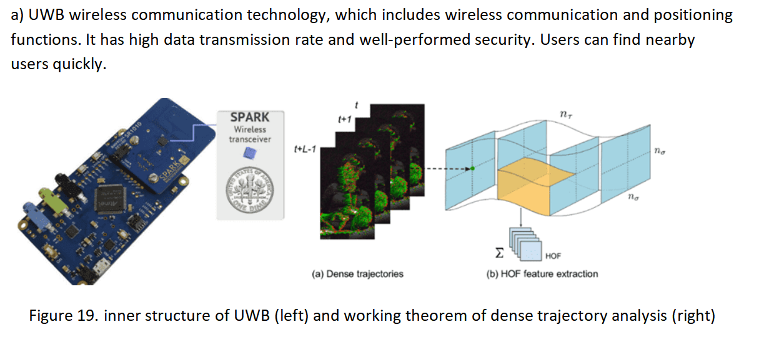

Figure 12. inner structure of UWB (left) and working theorem of dense trajectory analysis (right)

**Step3: Designing Product Functional Flow**

After our group discussions and meetings, we decided that the product should mainly serve two ends: recycling companies and residents. Recycling companies and residents use the platform with different focuses and different operational processes.

1. Company Operating Procedures



Figure 13. Company operating procedures

The staff will regularly issue QR code stickers to the users and collect the waste materials from the self-service recycling bins at regular intervals. After the waste products are retrieved, they will be weighed, scanned, unpacked, information verification and other processing links, and eventually the staff will upload the collected data to the company's database and enter the user's points into the "waste collection" software.

1. Resident Operating Procedures

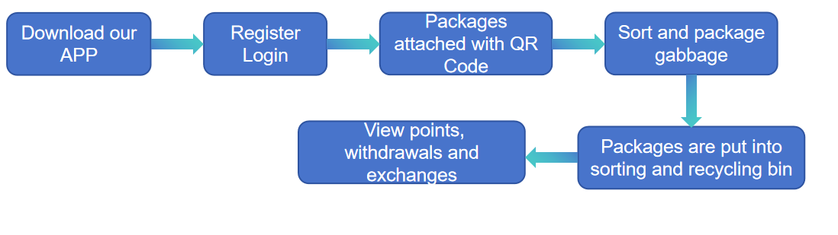

Figure 14. Resident operating procedures

The user downloads the APP, registers and logs in. To dispose of garbage, users first sort and pack the garbage; then stick a QR code sticker on the garbage bag and open the APP to scan the QR code; and finally put the garbage into the corresponding category port of the self-service garbage recycling box. After completing the above three steps, you only need to wait for the staff to confirm, and then you can log in the APP to check the points. The points in the app can be used to withdraw cash or exchange for goods.

1. General operation flow chart

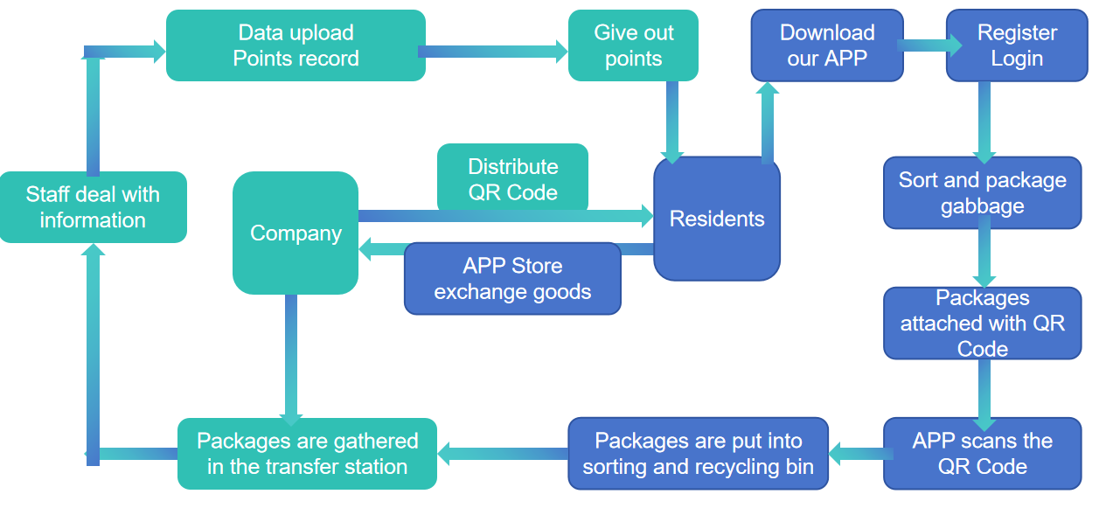

Figure 15. General operation flow chart

## Step4：Confirmation of platform functionality presentation and UI design

In this step, we use Photoshop software to integrate the functions required by the product platform, and design a set of more complete platform display demo. 



Figure 16. The platform function presentation and UI design

Through the above steps, we recognize the feasibility of this product. At the same time, the combination of hardware and software to realize the whole chain process of garbage classification and recycling belongs to a technological innovation point, and the convenience and ease of use can also better improve the one-stop service of garbage classification and recycling, and our product will become a bridge between the company and the users, better realize the social public welfare concept, and respond to the national concept of sustainable development, and become a leader of the domestic garbage classification and recycling industry.

## Testing

## Step1: Profit Model Analysis

We put "Classified With Earnings" APP into APP Store and Android App Market, all users can download and use it for free. In the early stage, the company's profit mainly comes from the recycling spread and shopping mall profits, as well as advertising and information fees charged by merchants. With the full spread of recycling outlets and the increase in the number of registered APP users, the Company will expand the proportion of advertising revenue and information fee in the middle and late stages of profitability.

(a) Recycling spread

Recycling gross profit is the main source of income in the early stage of operation. The gross profit margin of waste recycling varies depending on the type of waste, with an average gross profit margin of around 10%.

b) Mall goods profit

We use the "Classified Earn" APP to provide a platform for merchants to publicize and promote their goods. Users can exchange their points for commodities by purchasing the full amount of points or offsetting part of the price of the commodities, and our company earns the full profit of the commodities.

c) Advertising fee

Sort & Earn" APP home page has 7 advertisement spaces for rent to merchants. Our company will attract merchants and enterprises with the steady growth of the number of users, collect advertising fees and realize profits.

d) Information Fee

Staff will record user information during each door-to-door recycling service, including age range, contact information, type of waste, quantity of waste, etc., so as to build a database of user behaviours.

## Step2: Market feasibility analysis

a) Market Basis

On the one hand, China's waste separation and recycling market is huge and growing rapidly; on the other hand, there is either a lack of effective recycling mechanisms in the market or users are not satisfied with the existing measures. The "Sort&Earn" APP launched by this project not only establishes an efficient and effective recycling mode but also brings certain economic incentives, and a high proportion of users are willing to use the "Sort&Earn" APP, so the market foundation is good.

b) Competitive Advantages

The "Sort&Earn" APP launched by this project establishes a brand new mode of collecting waste with technology, and has advantages over traditional waste recycling methods in many aspects.

Table 5. The advantages of our platform

## Step3: Target Market Analysis

1.Target Market Selection:

In order to determine the target market of the APP, so as to effectively cover the potential users and reduce the market risk, we designed a questionnaire for a random sample of Beijing neighborhoods. After statistical analysis, we found that:

Based on the type of community: the medium and high-class communities are better than other ordinary or non-property communities in terms of their knowledge of waste classification, waste classification and disposal rate, and acceptance of APP use.

In terms of the type of community: although the rate of garbage classification and disposal is lower among young people such as office workers and college students, their knowledge of garbage classification, willingness to classify garbage, smartphone ownership and acceptance of APP use are all better than those of other communities.

Therefore, we believe that middle and high-grade neighborhoods and higher education parks are more suitable for the promotion and operation of the project. On the one hand, users in the target market know more about garbage classification, which reduces the education cost and promotion risk; on the other hand, users in the target market have a stronger willingness to classify garbage, which has a greater market potential.

2.Target Market Characteristics:

* Higher education campus user market:

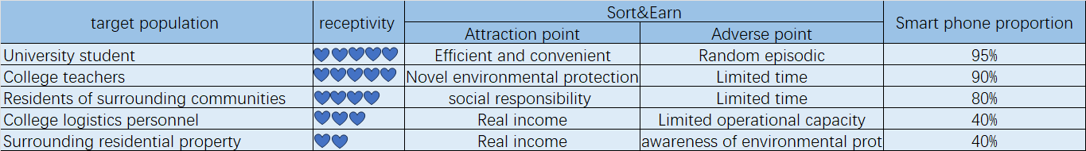

Table 6. Higher Education Campus User Market Analysis

* Mid- and Upper-Architecture Neighborhood Users Market:

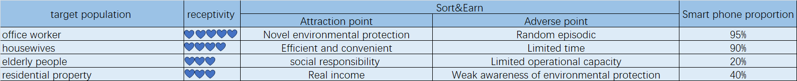

Table 7. Market Analysis of Users in Mid- and Upper-End Neighborhoods.

After reflecting and summarizing the whole process, we can draw the following conclusions: Firstly, we have extensively collected market characteristics of different user markets and identified user markets suitable for promoting our product. Secondly, our product has great potential and fills a gap in the market. Finally, we have a well-developed profit model. Therefore, it can be said that our product will be strongly supported by the market.

# Conclusion

Our findings indicate a significant market opportunity, driven by society's increasing focus on sustainability and efficient recycling of resources. The user-friendly design coupled with the reward system is expected to significantly increase the recycling rate among the target population such as students and urban dwellers.

Improvements

Our analysis also highlights several areas for further development. Technology implementations, while robust, need to be continually updated and security strengthened to protect user data and ensure system integrity.

The physical infrastructure for waste collection and recycling also needs to be expanded to cover a wider area and to meet the growing application needs of users.

User feedback indicates that there is a need to improve the transparency of the recycling process and to provide more diversified incentive options in order to increase user engagement and satisfaction.

Finding

In conclusion, the Sort&Earn application demonstrates significant market potential with its innovative approach to waste management. Through targeted improvements and continued user-centered development, this digital product will not only promote environmental sustainability, but also provide a profitable investment opportunity in the green technology market.

# List of References

1. Li, F. (2021) Personalized e-commerce recommendation system based on user history behaviour sequence. 11(33), 59-62. Available from: doi: 10.19981/ j.cn23-1581 /G3.2021.33.014
2. Oppermann, I. (2004). UWB Theory and Applications. JohnWiley & Sons google schola, 2, 98-153.

# Appendix

Since the platform code is long, only some of the main functional code is selected here as a showcase.

1. // pages/home/home.js
2. const app = getApp()
3. const {
4. $Toast
5. } = require('../../assets/dist/base/index');
6. Page({
7. data: {
8. name: app.globalData.nickName,
9. userInfo: {},
10. hasUserInfo: false,
11. canIUse: wx.canIUse('button.open-type.getUserInfo'),
12. orderList: [{
13. name: 'salavtore',
14. phone: ‘telephone',
15. time: 'Monday',
16. recyclerName: 'Damon',
17. recyclerPhone: 'test',
18. address: 'testAdd'
19. }]
20. },
21. onLoad: function(options) {
22. this.initUserInfo();
23. this.initOrderList();
24. },
25. initOrderList: function() {
26. var that = this;
27. wx.request({
28. url: app.globalData.url+'getOrderListByName',
29. data: {
30. name: that.data.name,
31. },
32. header: {
33. "Content-Type": "applciation/json"
34. },
35. method: "GET",
36. success: function(res) {
37. console.log(res.data);
38. that.setData({
39. orderList: res.data
40. })
41. },
42. fail: function(err) {},
43. complete: function() {}
44. })
45. },
46. // initialize
47. initUserInfo: function() {
48. if (app.globalData.userInfo) {
49. this.setData({
50. userInfo: app.globalData.userInfo,
51. name: app.globalData.nickName,
52. hasUserInfo: true
53. })
54. } else if (this.data.canIUse) {
55. app.userInfoReadyCallback = res => {
56. this.setData({
57. userInfo: res.userInfo,
58. name: res.userInfo.nickName,
59. hasUserInfo: true
60. })
61. }
62. } else {
63. //special case dealing
64. wx.getUserInfo({
65. success: res => {
66. app.globalData.userInfo = res.userInfo
67. this.setData({
68. userInfo: res.userInfo,
69. name: res.userInfo.nickName,
70. hasUserInfo: true
71. })
72. }
73. })
74. }
75. },
76. getUserInfo: function(e) {
77. console.log(e)
78. app.globalData.userInfo = e.detail.userInfo
79. this.setData({
80. userInfo: e.detail.userInfo,
81. hasUserInfo: true
82. })
83. },
84. onReady: function() {
85. },
86. onShow: function() {
87. this.onLoad();
88. },
89. onHide: function() {
90. },
91. onUnload: function() {
92. },
93. onPullDownRefresh: function() {
94. },
95. onReachBottom: function() {
96. },
97. /**
98. * share
99. */
100. onShareAppMessage: function() {
101. },
102. handleUpdate: function(detail) {
103. let id = detail.currentTarget.dataset.id;
104. let name = detail.currentTarget.dataset.name;
105. wx.navigateTo({
106. url: '/pages/orderUpdate/orderUpdate?orderId=' + id + '&name=' + name
107. })
108. },
109. // Deleteorders
110. deleteOrder: function(orderId) {
111. var that = this;
112. wx.request({
113. url: app.globalData.url+'deleteOrder', //request address
114. data: {
115. id: orderId,
116. },
117. header: {
118. "Content-Type": "applciation/json"
119. },
120. method: "GET",
121. success: function(res) {
122. console.log(res.data);
123. that.onLoad();
124. },
125. fail: function(err) {}, //request failed
126. complete: function() {} //request success
127. })
128. },
129. handleCancle: function(detail) {
130. console.log(detail);
131. let id = detail.currentTarget.dataset.id;
132. var that = this;
133. wx.showModal({
134. content: 'Delete？',
135. success: function(res) {
136. if (res.confirm) {
137. that.deleteOrder(id);
138. }
139. }
140. });
141. }
142. })

Part of the code for the platform's partial product exchange function is as follows.

1. // pages/order/order.js
2. const { $Toast } = require('../../assets/dist/base/index');
3. const app = getApp();
4. Page({
5. data: {
6. name: '',
7. phone: '',
8. address: '',
9. time: '',
10. recyclerName: '',
11. recyclerPhone: '',
12. recyclerPhoto: ''
13. },
14. // name: function (e) {
15. //   this.setData({
16. //     name: e.detail.detail.value
17. //   })
18. // },
19. phone: function (e) {
20. this.setData({
21. phone: e.detail.detail.value
22. })
23. },
24. address: function (e) {
25. this.setData({
26. address: e.detail.detail.value
27. })
28. },
29. time: function (e) {
30. this.setData({
31. time: e.detail.detail.value
32. })
33. },
34. onLoad: function (options) {
35. this.setData({
36. recyclerName: options.name,
37. recyclerPhone: options.phone,
38. recyclerPhoto: options.photo,
39. name: app.globalData.nickName,
40. })
41. console.log(this.data);
42. },
43. onReady: function () {
44. },
45. onShow: function () {
46. },
47. onHide: function () {
48. },
49. onUnload: function () {
50. },
51. onPullDownRefresh: function () {
52. },
53. onReachBottom: function () {
54. },
55. onShareAppMessage: function () {
56. },
57. handleOrder: function () {
58. console.log(this.data);
59. this.order();
60. },
61. order:function(){
62. var that = this;
63. wx.request({
64. url: app.globalData.url+'handleorder',
65. data: {
66. name: that.data.name,
67. phone:that.data.phone,
68. address:that.data.address,
69. time:that.data.time,
70. recyclerName:that.data.recyclerName,
71. recyclerPhone:that.data.recyclerPhone,
72. recyclerPhoto:that.data.recyclerPhoto
73. },
74. header: {
75. "Content-Type": "applciation/json"
76. },
77. method: "GET",
78. success: function (res) {
79. console.log(res.data);
80. if (res.data == 1) {
81. $Toast({
82. content: "success",
83. });
84. setTimeout(() => {
85. wx.navigateBack({
86. delta: 1
87. });
88. }, 1000);
89. } else {
90. $Toast({
91. content: "failed"
92. });
93. }
94. },
95. fail: function (err) { },
96. complete: function () { }
97. })
98. },
99. handleCancle: function () {
100. wx.navigateBack({
101. delta: 1
102. });
103. }
104. })

The platform garbage collection function part of the code is as follows.

1. // pages/recycle/recycle.js
2. const { $Message } = require('../../assets/dist/base/index');
3. const app = getApp();
4. Page({
5. data: {
6. recyclers: [
7. {
8. name: "",
9. photo: "",
10. phone:"",
11. description: ""
12. }
13. ]
14. },
15. onLoad: function (options) {
16. this.getAllRecyclers();
17. },
18. getAllRecyclers:function(){
19. var that = this;
20. wx.request({
21. url: app.globalData.url+'getAllRecyclers',
22. data: {},
23. header: {
24. "Content-Type": "applciation/json"
25. },
26. method: "GET",
27. success: function (res) {
28. console.log(res.data);
29. that.setData({
30. recyclers: res.data
31. })
32. },
33. fail: function (err) { },
34. complete: function () { }
35. });
36. },
37. onReady: function () {
38. },
39. onShow: function () {
40. },
41. onHide: function () {
42. },
43. onUnload: function () {
44. },
45. onPullDownRefresh: function () {
46. },
47. onReachBottom: function () {
48. },
49. onShareAppMessage: function () {
50. },
51. handleOrder:function(event){
52. console.log(event);
53. wx.navigateTo({
54. url: '/pages/order/order?name=' + event.currentTarget.dataset.name + '&phone=' + event.currentTarget.dataset.phone + '&photo=' + event.currentTarget.dataset.photo
55. })
56. }
57. })

The questionnaire design is shown below.

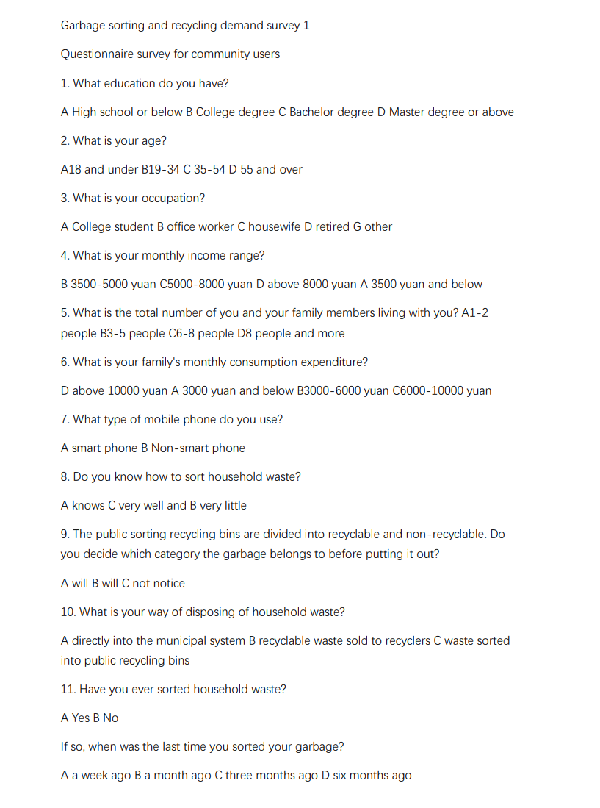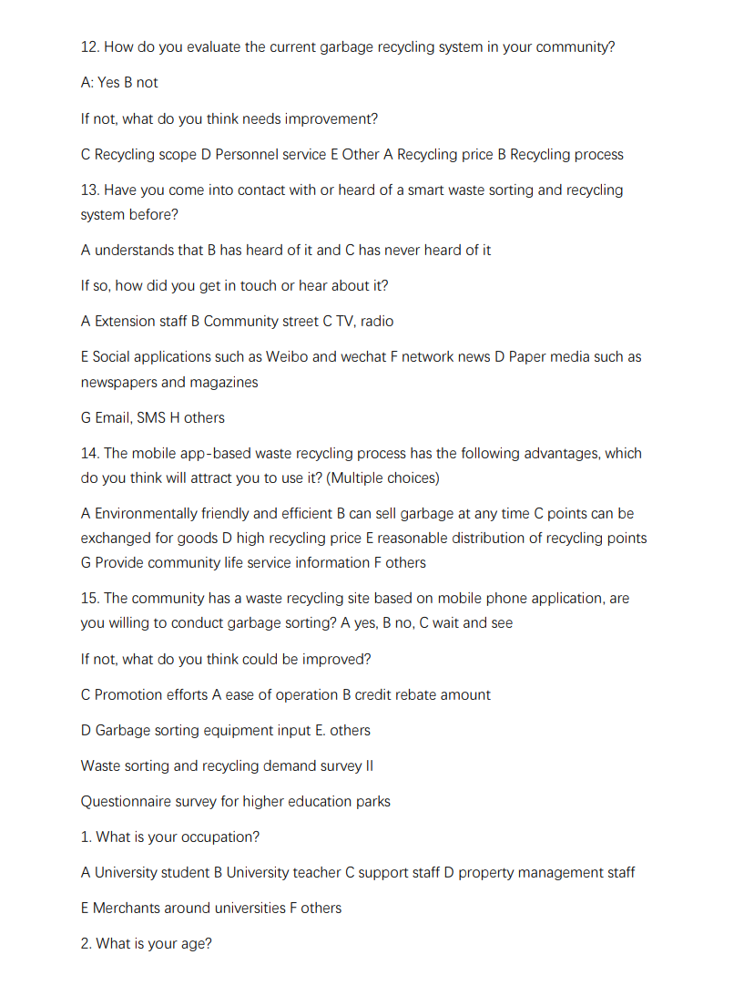

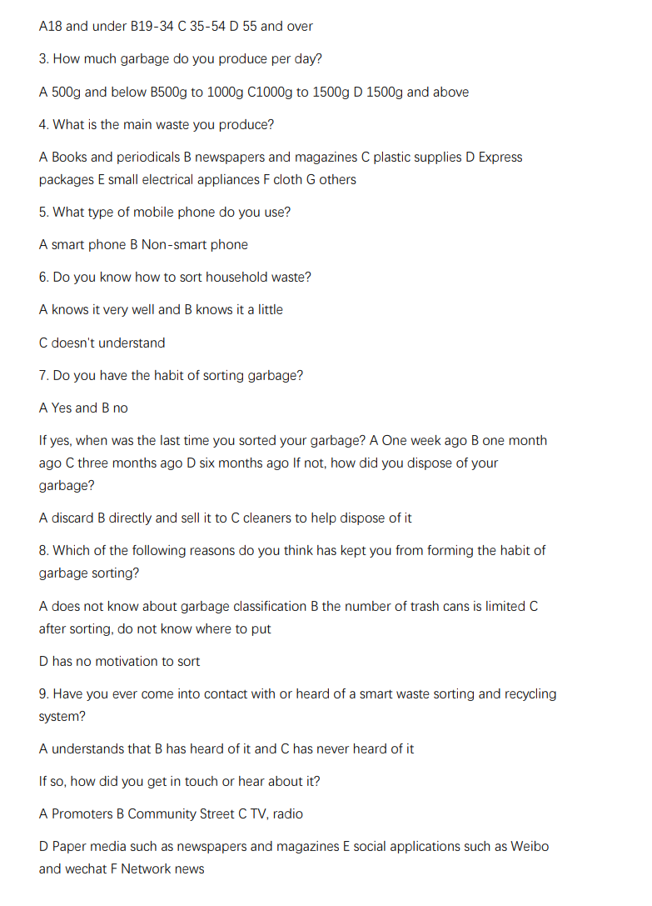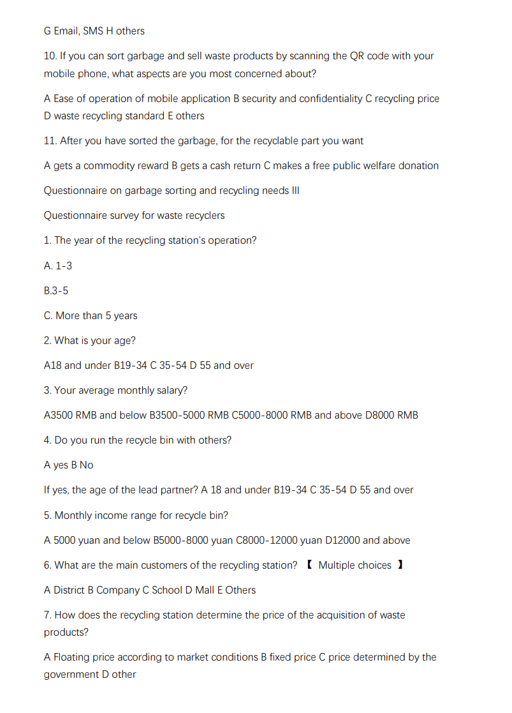

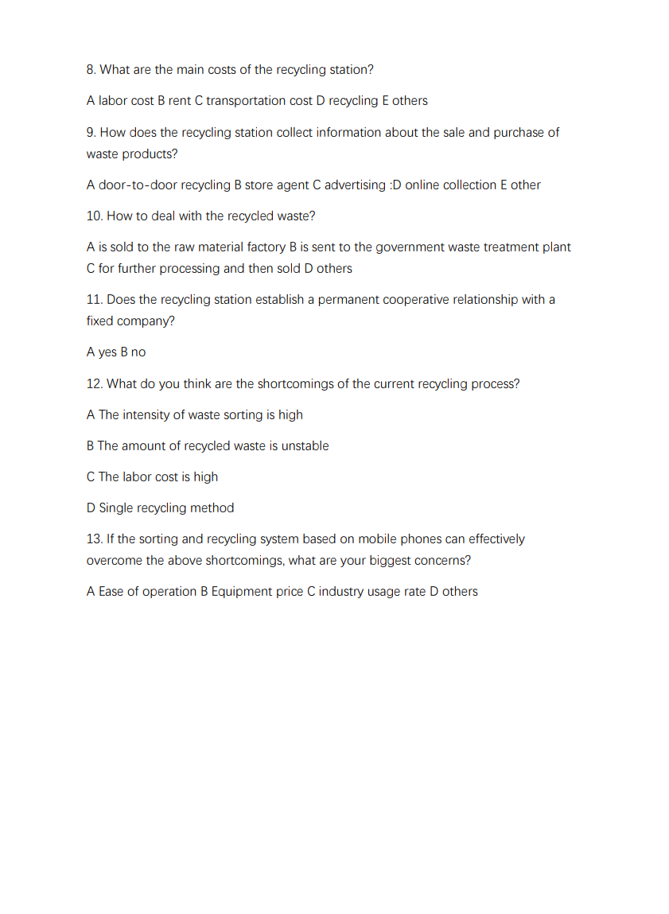Coursework Meeting Logbook

|  |  |  |  |  |  |
| --- | --- | --- | --- | --- | --- |
| Members of the Team | | | | | |
| Role | Given Name | Family name | BUPT number | QMUL number | Class Number |
| Leader | Ling | Tang | 2022213457 | 221169302 | 2022215115 |
| Member | Zhimu | Zhou | 2022213459 | 221169324 | 2022215115 |
| Member | Shuyi | Wei | 2022213454 | 221169276 | 2022215115 |
| Member | Yuxuan | Zhong | 2022213435 | 221169092 | 2022215115 |
| Member | Zecheng | Zuo | 2022213434 | 221169081 | 2022215115 |
| Project Title | Sort&Earn | | | | |

|  |
| --- |
| **Date:** 26-03-2024  **Meeting type:** face-to-face meeting  Topics Discussed:  1. Members share prepared product ideas with each other  2. Brainstorm and discuss your proposed ideas  3. Preliminary screening, decide the final product as garbage sorting and recycling APP  Tasks to be achieved by next meeting:  1. Investigate relevant materials and share them at the next meeting  2. Make specific division of labor, and divide the work after carefully reading the teaching requirements  Next meeting (date/time):    02-04-2024  **Date:** 02-04-2024  **Meeting type:** online meeting  Topics Discussed:  1. Members share the work progress of the week and synchronize information  2. Share the harvest of research  3. Discuss submission requirements and split the product documentation work  Tasks to be achieved by next meeting:  1. Conduct market research to see if the idea is feasible  2. Discuss the progress of this week's work, raise specific difficulties encountered in the meeting, and discuss and solve them in a timely manner  Next meeting (date/time):   08-04-2024  **Date:** 08-04-2024  **Meeting type:** face-to-face meeting  Topics Discussed:  1. Synchronize the work progress of this week, share their work progress and specific difficulties  2. Optimize and modify the user survey questionnaire initially produced  Tasks to be achieved by next meeting:  1.Collect the results of our questionnaire about identifying  2. analyze the data of the user questionnaire. A brainstorm about what functions our product should meet and start to analyze the customer needs.  3. Prepare the design of APP product prototype drawing, and provide the general framework and scheme  Next meeting (date/time):   15-04-2024  **Date:** 15-04-2024  **Meeting type:** online meeting  Topics Discussed:  1.Collect the results of our questionnaire about identifying  2.Conduct data analysis of user questionnaires. A brainstorm about what functions our product should meet and start to analyze the customer needs.  3.Prepare the design of APP product prototype drawing, give the general framework and scheme  Tasks to be achieved by next meeting:  1.Complete the concept generation by steps.  2.Concept generation steps of our product, Search internally to find solutions about critical sub-problems about our product.  Next meeting (date/time):   21-04-2024  **Date:** 21-04-2024  **Meeting type:** face-to-face meeting  Topics Discussed:  1.Discussed the ideas to complete the testing and conclusion and divided testing into seven steps and conclusion into three parts. Everyone got a clear task.  Tasks to be achieved by next meeting:  1. Summarize and integrate the work of each member, discuss and modify it  2. Conduct final inspection of the final delivery, correct minor errors, and improve the deficiencies  Next meeting (date/time):  28-04-2024  **Date:** 28-04-2024  **Meeting type:** face-to-face meeting  Topics Discussed:  1. Each member shall review and verify the report, prepare to submit  2. After confirming that there is no problem, supplement the job description of the first division of labor according to the actual work content  3. The minutes taker will place the minutes in the Coursework Meeting Logbook  Tasks to be achieved by next meeting: NONE  Next meeting (date/time):   NONE |